Your License to Drive

Module 1 – Topic 2

- When a licensed driver moves to Virginia from another state, he/she will have 60 days to obtain a Virginia driver’s license.

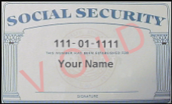
- List 4 items you can use to verify your social security number.

1. 3.

2. 4. I

- If you are under the age of , you must provide written parental consent to obtain a learner’s permit.

- In order to get a learner’s permit in Virginia, you must be at least years and 6 months months old.

- A learner’s permit allows you to practice driving with a licensed driver at least years old or with an immediate family member at least years old with a valid license.

- When taking the learner’s permit written tests, you must score 100% on the test and at least 8 % on the general knowledge test.

- Persons less than 18 need form(s) of identification when applying for a learner’s permit.

- In order to obtain a 90-day provisional driver’s license, you must be at least years and 3 months old and, if under 19, have held a learner’s permit for months.

- Before receiving your provisional license, your parents/guardians or foster parents must certify that you have driven at least hours, of which were after sunset.

- Describe how to obtain a motorcycle driver’s license.
.

- Name 3 documents that DMV will accept as proof of residency.

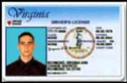
- Check the license below that is issued to a driver younger than 21 years old.


- What does a red heart on a license mean?

- Name 5 organs that can be successfully transplanted.
1.
2.
3.
4.
5.

- Persons less than 18 may become organ donors with permission.

  - Why are restrictions placed on a driver’s license?

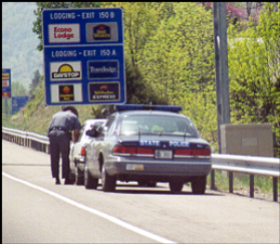
    - A person with 20/70 or better vision in one or both eyes would be restricted to .

    - What is the difference between license suspension and revocation?
.

- No learner’s permit holder may operate a motor vehicle with more than non-family passenger(s) less than 18 except when participating in an approved driver education program.

- Driving between the hours of & is prohibited for holders of learner’s permits.

- A driver’s license is valid for years and expires on at ages divisible by 5.

- What does the “implied consent” mean?
.

- Persons less than 21 who drive with a BAC of at least .02 but less than .08 may lose their driver’s license for 6 months under the law.

- In Virginia, all vehicles must have insurance, or the owner must pay the fee of $ .

Module 1 – Topic 3
Right of Way Concepts
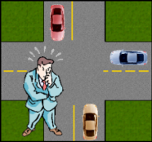
- What is the underlying principle of right-of-way rules?

- At the following uncontrolled intersection, indicate who has the right of way.

Car A
Car B
No one

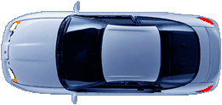
A



B

- In the above situation, indicate who must yield.

- In the following situations, indicate which vehicle must yield: (Place an answer box for each diagram)
A
A
B
B
B
Top of Form

Bottom of Form
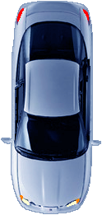
a. b.
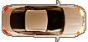
A
B
A

c. d.

IN EVERY SITUATION, RIGHT OF WAY MUST BE GIVEN BY A DRIVER, NOT TAKEN BY A DRIVER!

- At traffic circles (roundabouts), vehicles shall yield to vehicles

.

- Describe what you should do when you approach this sign?

- You must stop for a stopped school bus loading or unloading students unless there is a between your vehicle and the school bus.
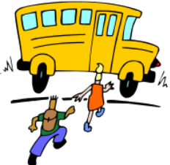

- You are driving on a 2-lane roadway when you notice a rescue vehicle approaching from the rear with its lights and siren on. What should you do?
.

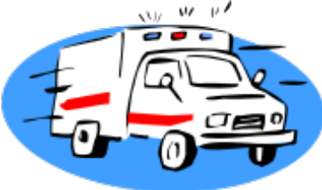

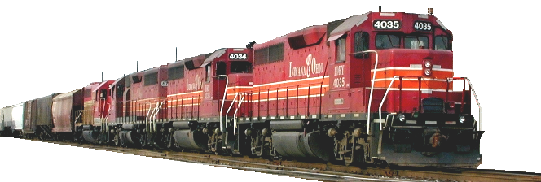
Railroad Safety
Module 1 – Topic 3a

- Most highway-rail crashes are the result of .

- A train traveling 50 mph takes approximately to stop.

- What should you do if your vehicle stalls while crossing the railroad tracks?

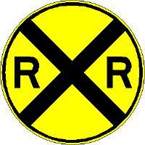
- When you see this sign, you should:

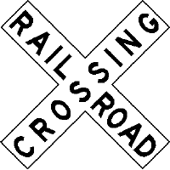
- This sign is the same as a sign.

- List 6 railroad crossing safety tips.
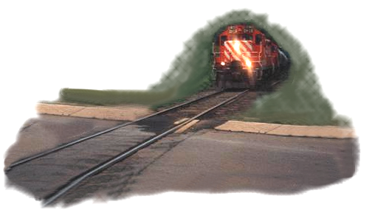

Module 1 – Topic 4
Signs, Signals & Pavement Markings


- Give the meaning of a:

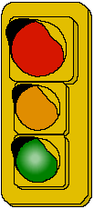

Steady red light Flashing red light Flashing yellow light

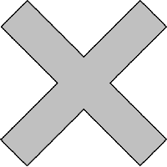
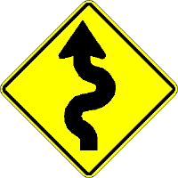
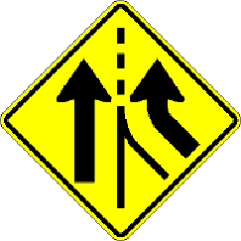

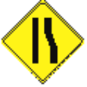
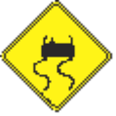
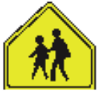




- Give the meaning of each sign shape:

1 2 3 4

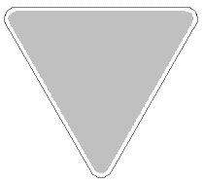
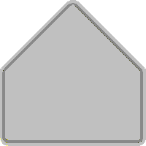

5 6 7

- Match each sign color with its meaning.

orange B. yellow C. blue D. green

E. red F. brown G. fluorescent optic yellow

-prohibitive - school or pedestrian crossing

.- general warning -recreation area

- motorist services -directions

-workzone

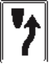
- This sign means:

Roadway Markings

  - A solid line indicates .

  - A broken line indicates .

  - A yellow line indicates .

  - A white line indicates .

  - A broken yellow line indicates and .

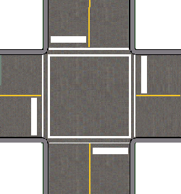
    - What is the meaning of the thick white lines in this diagram?

- Whenever you see , THINK WORK ZONE!

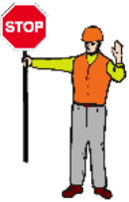
- What potential dangers do drivers encounter in a work zone?

- List 6 safety tips for driving through a work zone.

1-
2-
3-
4-
5-
6-

- Signal at least feet before you turn.

- This hand signal indicates a turn.
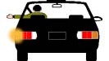

- Name five places where passing is not permitted.

- Parking is not permitted within

feet of a fire hydrant

feet of an intersection

feet of fire trucks stopped while answering an alarm

feet of a railroad crossing

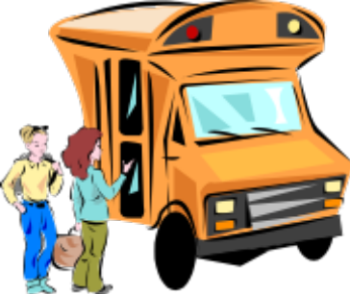
- The speed limit in school, business & residential areas is mph.

- The speed limit on a rural expressway is mph.



