Characteristics of Expressways
Module 6 – Topic 1

- List four characteristics of an expressway.



  - Describe why injuries suffered in expressway crashes are much worse than other crashes.

  - List 5 factors that contribute to a lower crash rate on expressways when compared to other roadways.

  - Identify each of the following interchanges:

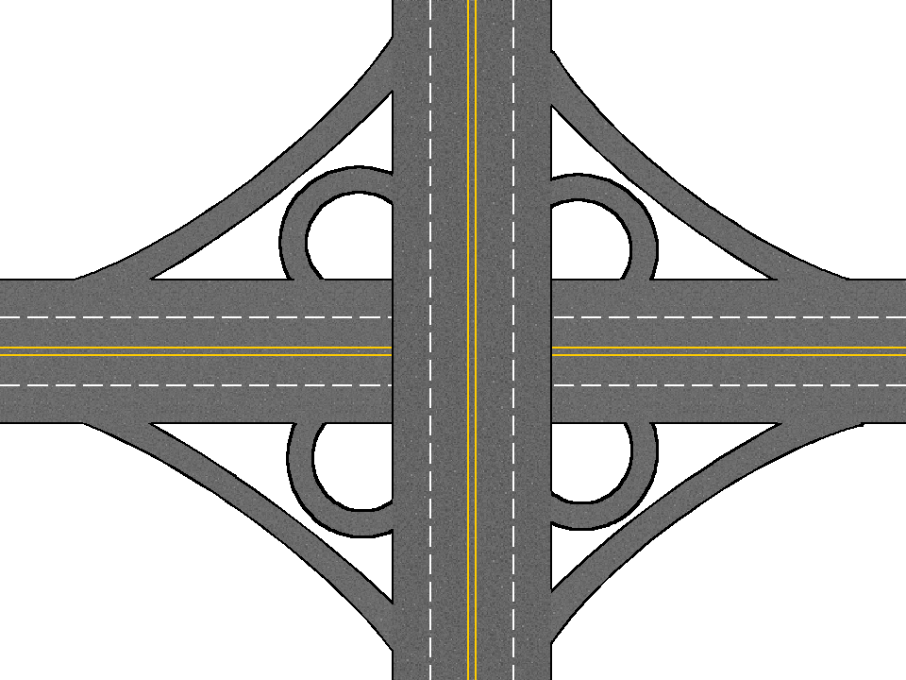
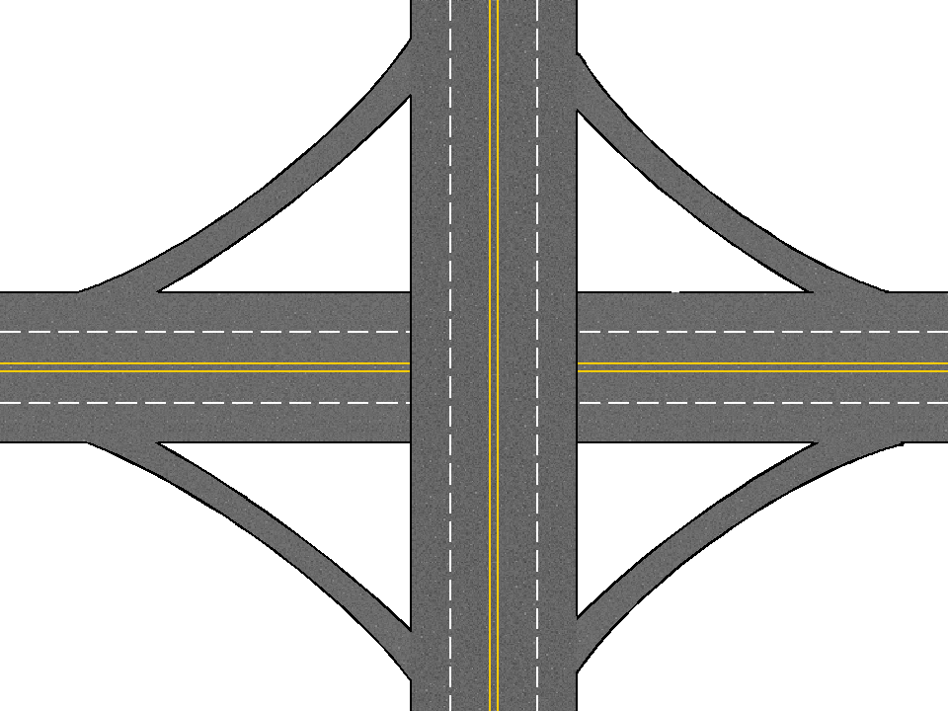
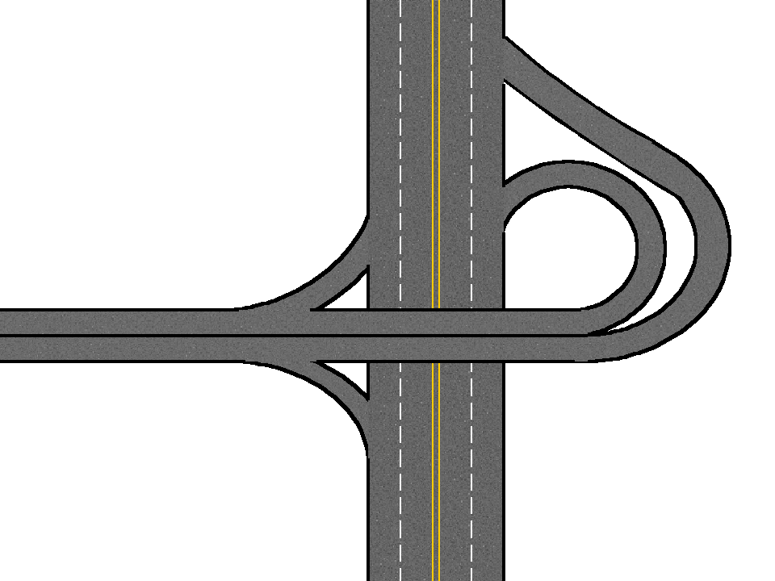
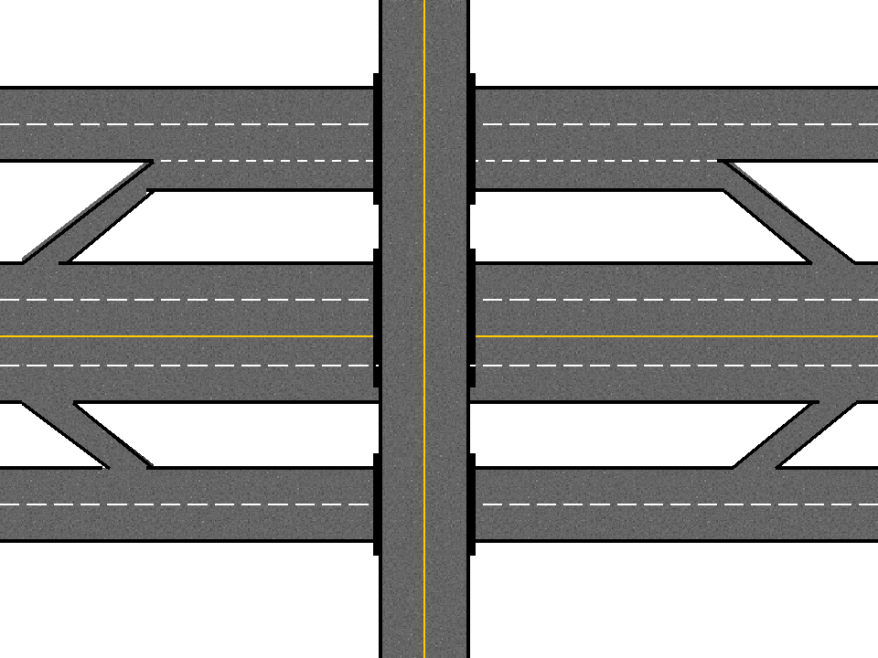

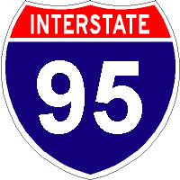

- Do vehicles traveling on interstate 95 travel north/south or east/west?

- An expressway lane with this pavement marking indicates:

  - In Virginia, the speed limit on rural expressways is mph.

Expressways

Module 6 – Topic 2
Entering/Changing Lanes/and Exiting

- The three parts of an expressway entrance are:
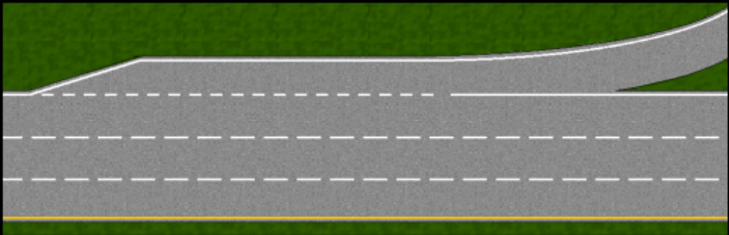
1
2
3

  - Describe the purpose of the acceleration lane:

- On expressways, the far right lane is usually used by

- Give four reasons to change lanes on an expressway.

- When changing lanes on the expressway, change lane at a time.

- Why is passing on the expressway safer than passing on 2 lane roadways?

- You should move to the lane closest to your exit ell ahead of the exit or at least seconds before the exit.

- Label the two parts of an expressway exit shown in the diagram below.

2
1



- The diagram below illustrates a lane in which traffic exiting and entering the expressway use the same ramp. The red vehicle is exiting and the blue vehicle is entering. The vehicle must yield to the other vehicle.
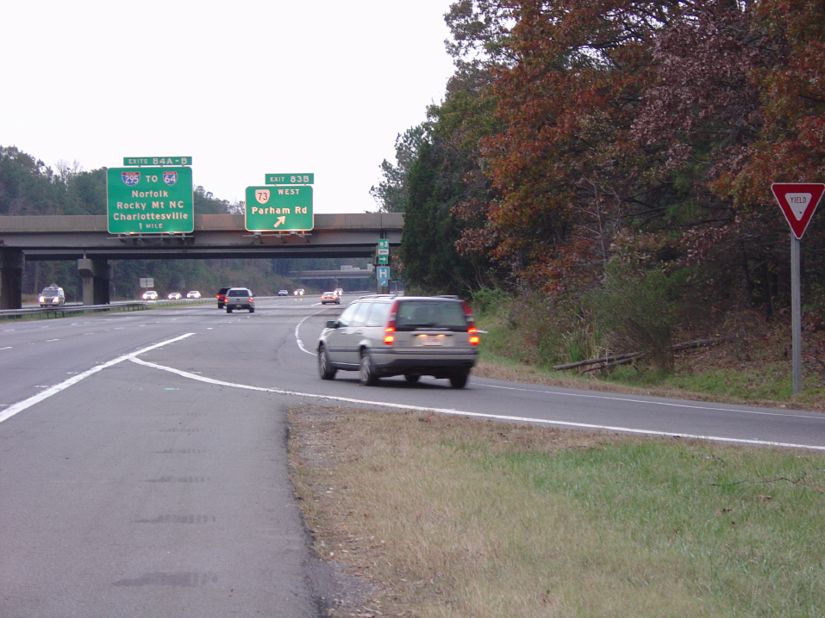



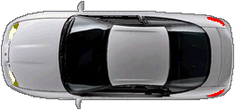

High Speed Considerations
Module 6 – Topic 3

- Why is highway hypnosis most likely to occur on rural expressways?

- What can drivers do to avoid highway hypnosis?

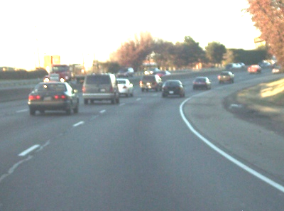

- Describe “wolf pack” driving?

  - Why is it dangerous?

- List 6 situations that would require increased following distance on an
expressway.

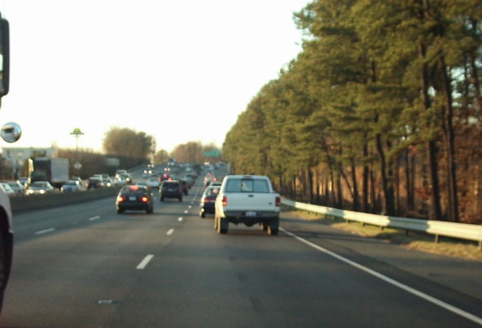
- How does driving on the expressway in or near cities differ from driving on the expressway in rural areas?

- When traveling on the expressway, why is it important to know entrance and exit numbers before you begin the trip?

- Describe 3 types of toll booths?

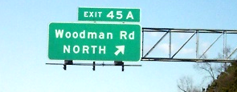

- You can determine if an exit is on the right or left by the position of the exit number on top of the exit sign. Exit 45A in this picture is a exit.

